SIMATS ENGINEERING
ASSESSMENT TOOL 2 - Medium(Assignment 1)
COURSE CODE: CSA09 COURSE NAME: Programming in Java COURSE OUTCOME COVERED
CO2: Implement Collection Framework interfaces such as List, ArrayList, Set, Map, HashTable, and HashMap using iterators and generics to store, retrieve, and process groups of objects in web applications.(BL3,BL4)
Assessment Tool Weightage: 10%
QUESTIONS: 40 (each student assigned distinct questions) Total Marks: 100
ANNEXURE A
Assignment 1
Code of Conduct:
I MONIKA G -192421158 (Name / Reg No) certify that this submission is my original work and that I have adhered to the guidelines specified for this assessment.
I understand that any violation of academic integrity rules will result in disciplinary action.
Signature of the student:
RUBRICS FOR CALCULATION:
Criteria | Level 4 (Exemplary) | Level 3 (Proficient) | Level 2 (Developing) | Level 1 (Beginning)
Problem Understanding
Algorithm
Code Implementation
Competitive Performance
Test Case Handling

Annexure A

Assignment 1

Question 15 – AI Chat History Manager

Problem Statement:
A chatbot stores user conversations for future reference.

Questions
- Develop a Java program using ArrayList.

CODE:
import java.util.*;
public class Main {
public static void main(String[] args) {
Scanner sc = new Scanner(System.in);
ArrayList<String> chat = new ArrayList<>();
System.out.print("Enter number of conversations: ");
int n = sc.nextInt();
sc.nextLine();
System.out.println("Enter Conversations:");
for(int i=0;i<n;i++)
{
chat.add(sc.nextLine());
}
System.out.println("\nChat History:");
for(String s : chat)
{
System.out.println(s);
}
}
}

OUTPUT:

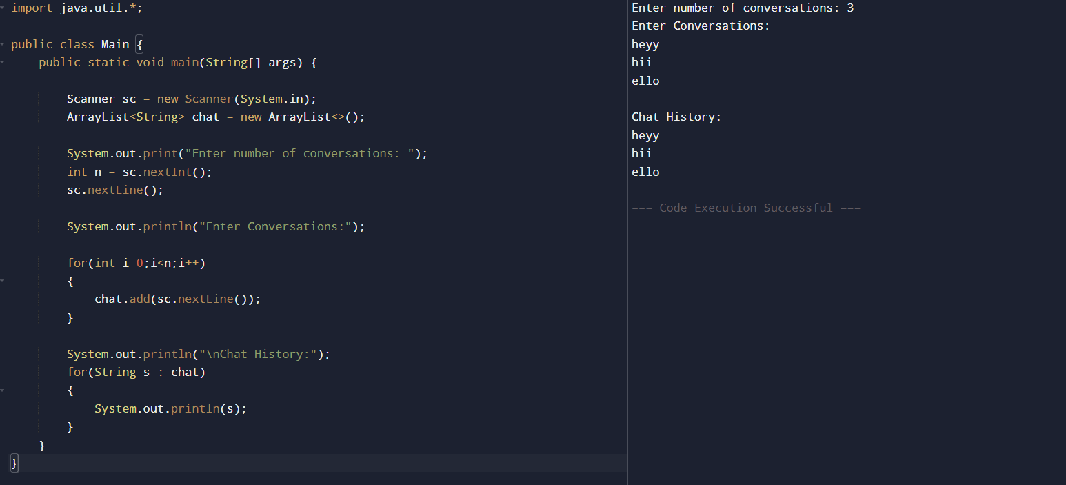

- Search conversations using Iterator.

CODE:

import java.util.*;
public class Main {
public static void main(String[] args) {
Scanner sc = new Scanner(System.in);
ArrayList<String> chat = new ArrayList<>();
chat.add("Hello");
chat.add("How are you?");
chat.add("Tell me about Java");
chat.add("Thank you");
System.out.print("Enter word to search: ");
String search = sc.nextLine();
Iterator<String> it = chat.iterator();
boolean found = false;
while(it.hasNext())
{
String msg = it.next();
if(msg.contains(search))
{
System.out.println("Found: " + msg);
found = true;
}
}
if(!found)
{
System.out.println("Conversation not found.");
}
}
}
OUTPUT:
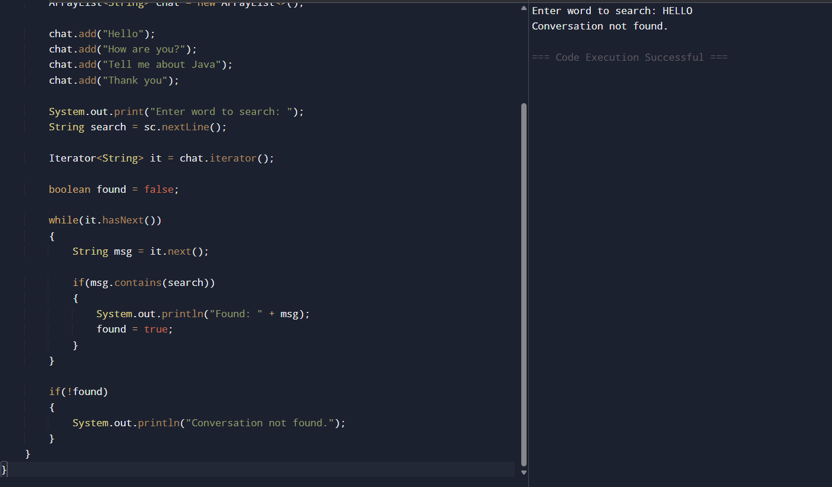

c) Compare ArrayList and Vector.

ArrayList | Vector
Not synchronized | Synchronized
Faster | Slower
Not thread-safe | Thread-safe
Better for single-thread applications | Better for multi-thread applications
Introduced in Java Collections Framework | Legacy class

Explanation
- ArrayList
  - Faster because it is not synchronized.
  - Used in most Java applications.
  - Suitable for single-threaded programs.
- Vector
  - Thread-safe because methods are synchronized.
  - Slightly slower due to synchronization.
  - Used when multiple threads access the same collection.
d) Discuss collections in conversational AI.
Explanation
Collections are used to efficiently store and manage chatbot data.
ArrayList
- Stores chat history in order.
- Allows fast retrieval using index.
LinkedList
- Stores conversation sequences.
- Efficient insertion and deletion.
HashSet
- Stores unique user IDs or unique messages.
- Automatically removes duplicates.
HashMap
- Stores question-answer pairs.
- Stores user information with unique keys.
Applications
- Chat history storage.
- User session management.
- Frequently asked questions (FAQ).
- Intent and response mapping.
- Conversation logging and analytics.

